Task : Create a role which only lets user1 and user2 from task 1 to have complete
access to VPCs and DynamoDB.
2. Login into user1 and shift to the role to test out the feature.

- Step1: Open AWS console > Search IAM > Under Access Management > Policies > Create Policy > Select a service > Service = EC2 > actions = all > resources = all .
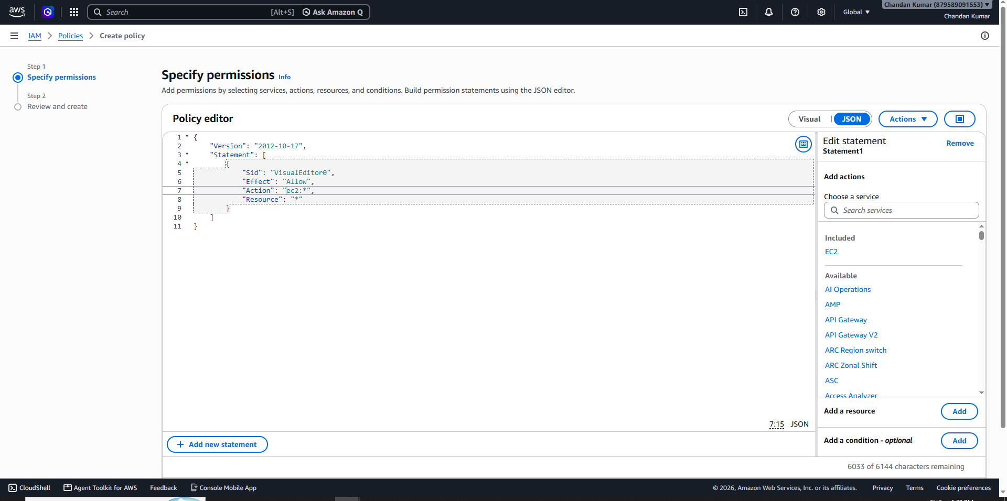
- Step 2: Click on add more permission > Select a service > Service = Dynamo DB > actions = all > resources = all > click on Next.
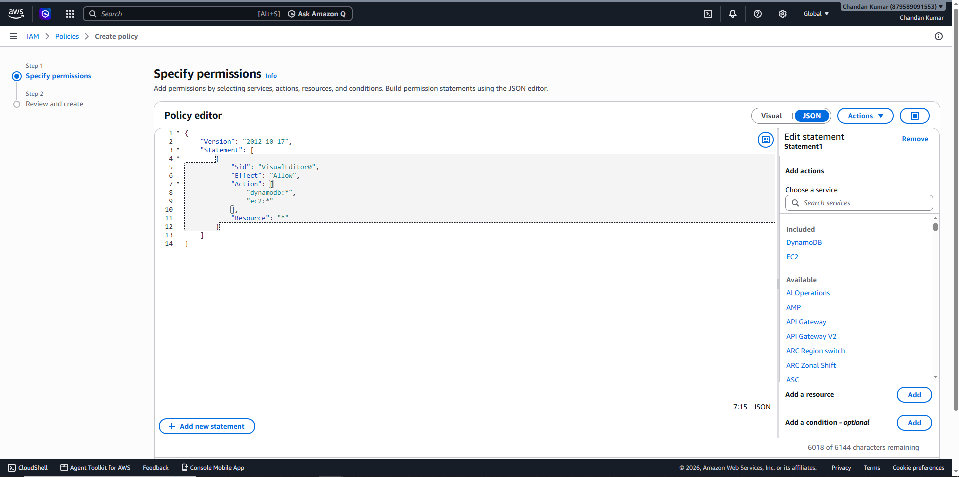
Step 3: Policy name = VPC_DynamoAccess > Click on Next.
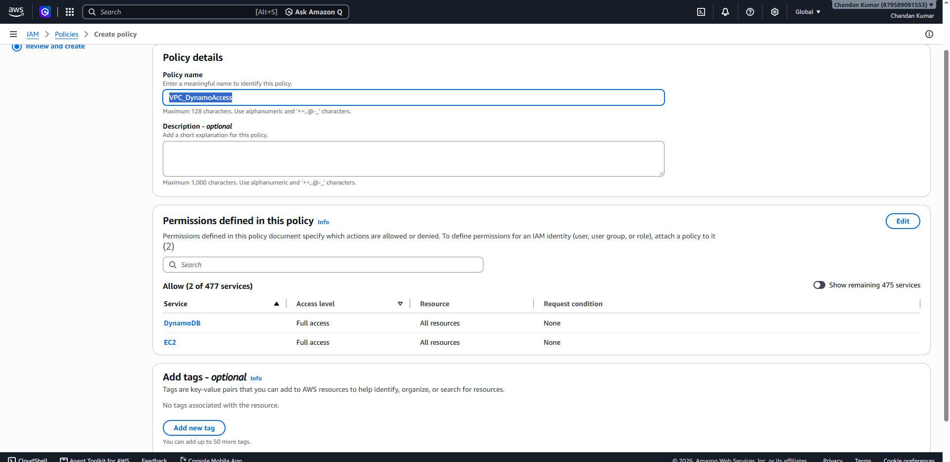
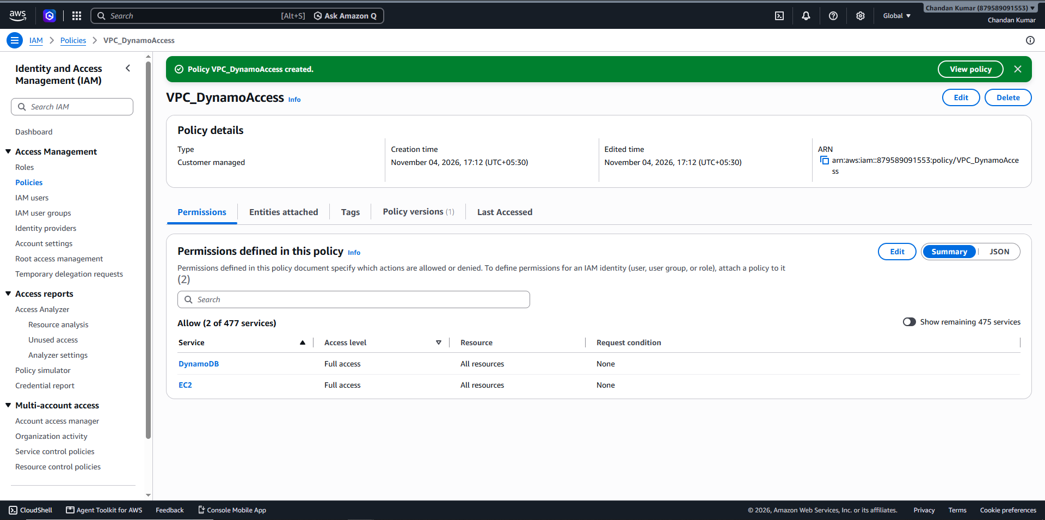
Step 4: In IAM > Identity and Access Management (IAM) > under Access Management > Click on roles > Click on create roles.
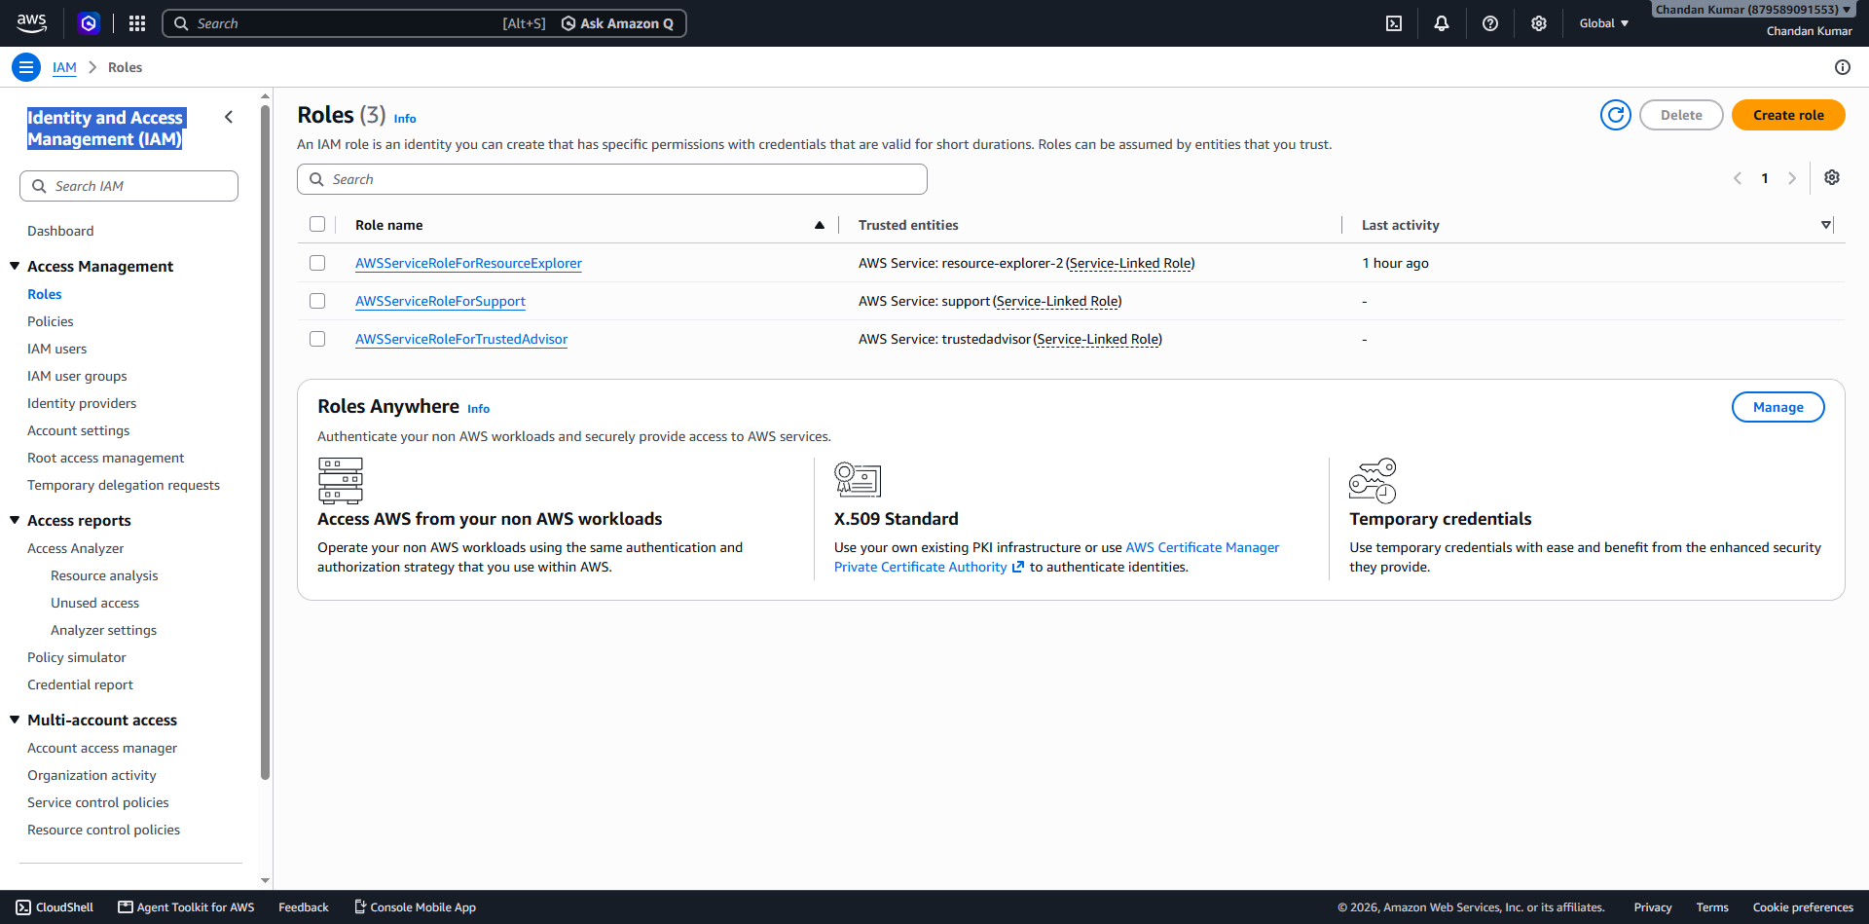
Step 5: Select trusted entity = AWS Account > An AWS account = This account (879589091553) > Next > Next > Role Name = Access_Role > Next > Create role.
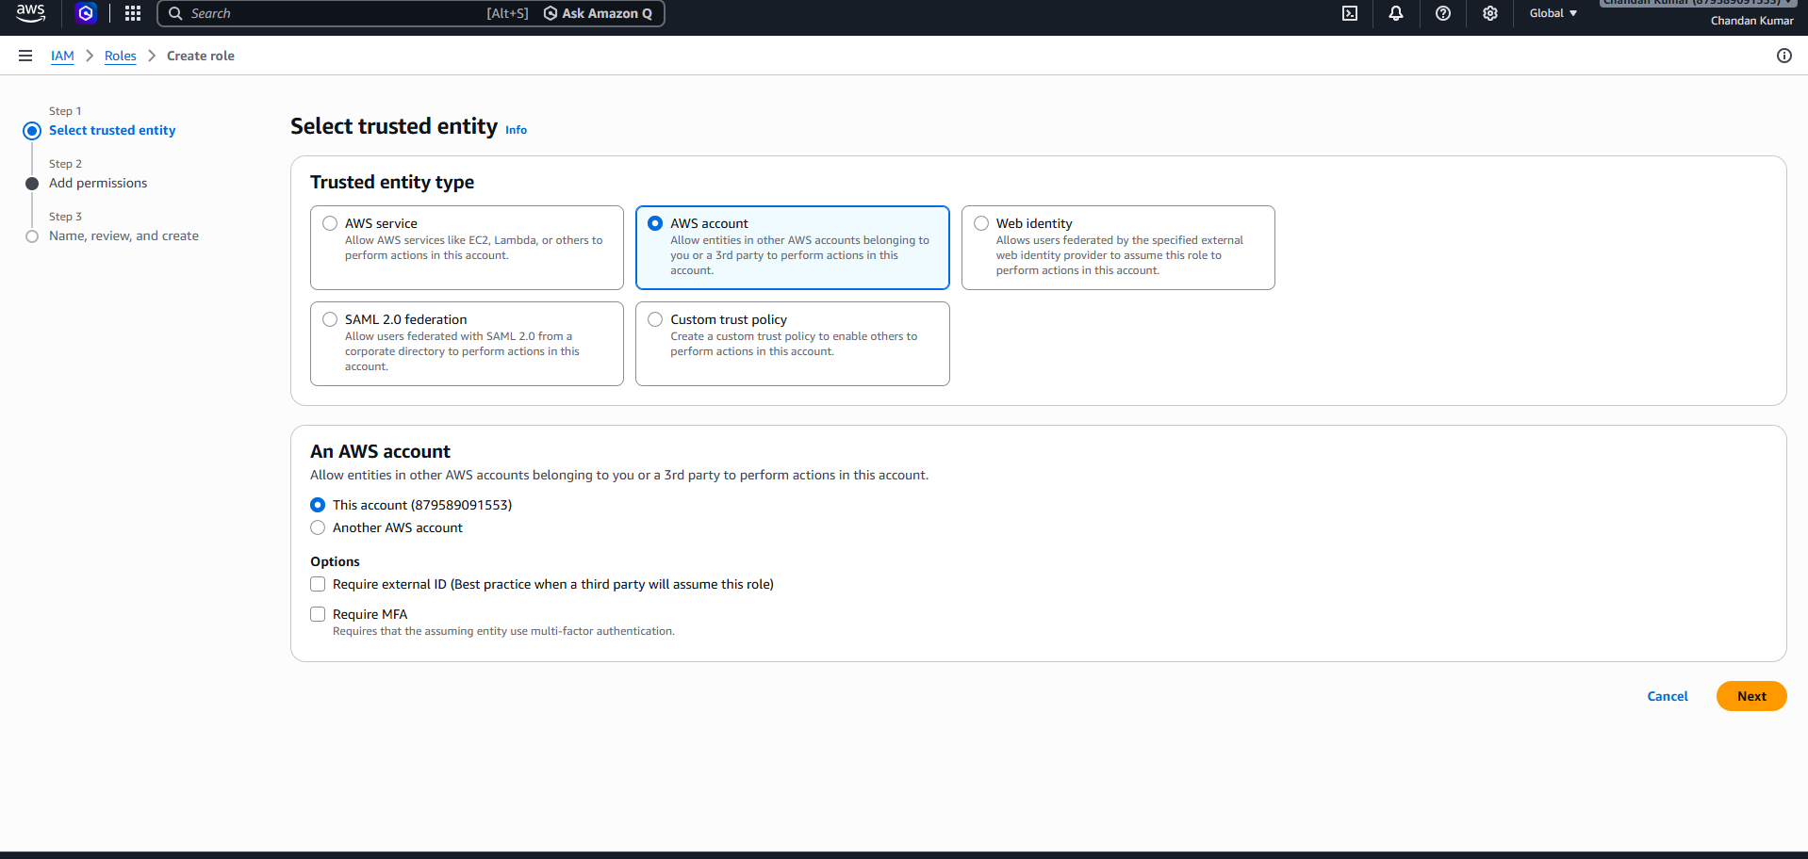
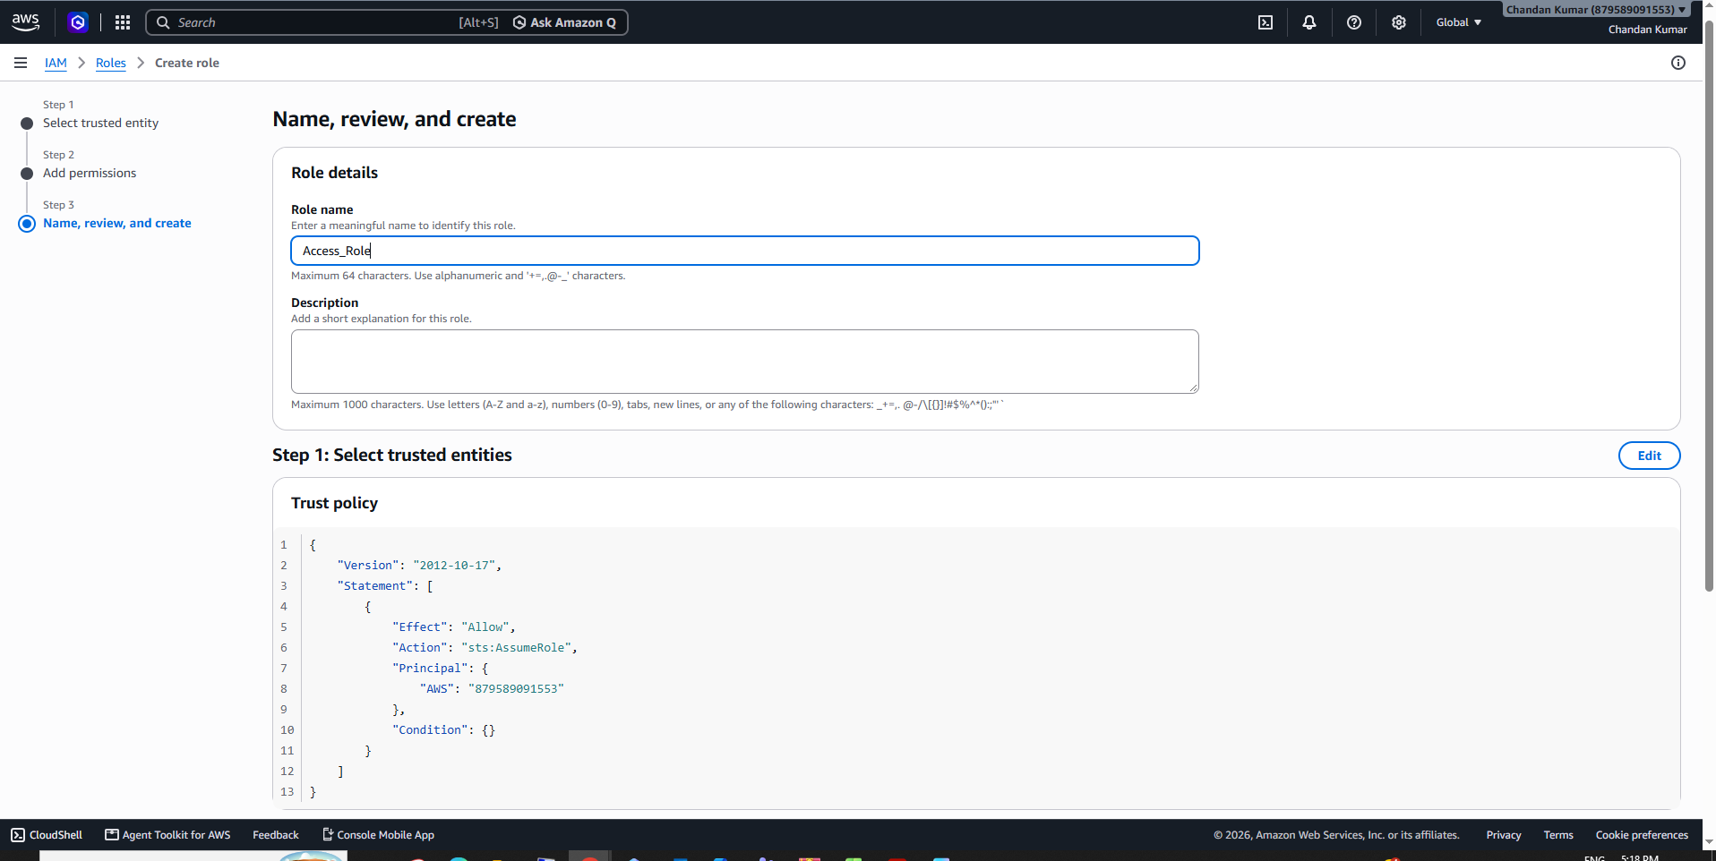
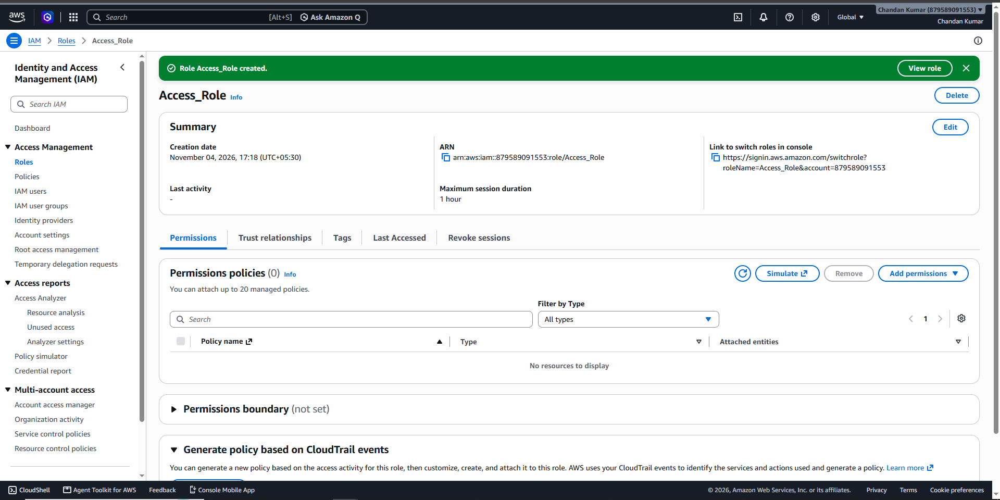
Step 6: Open your role (Access_Role) > Click on Trust Relationships > Edit your trust policy > add both users ARN > Click on update policy >
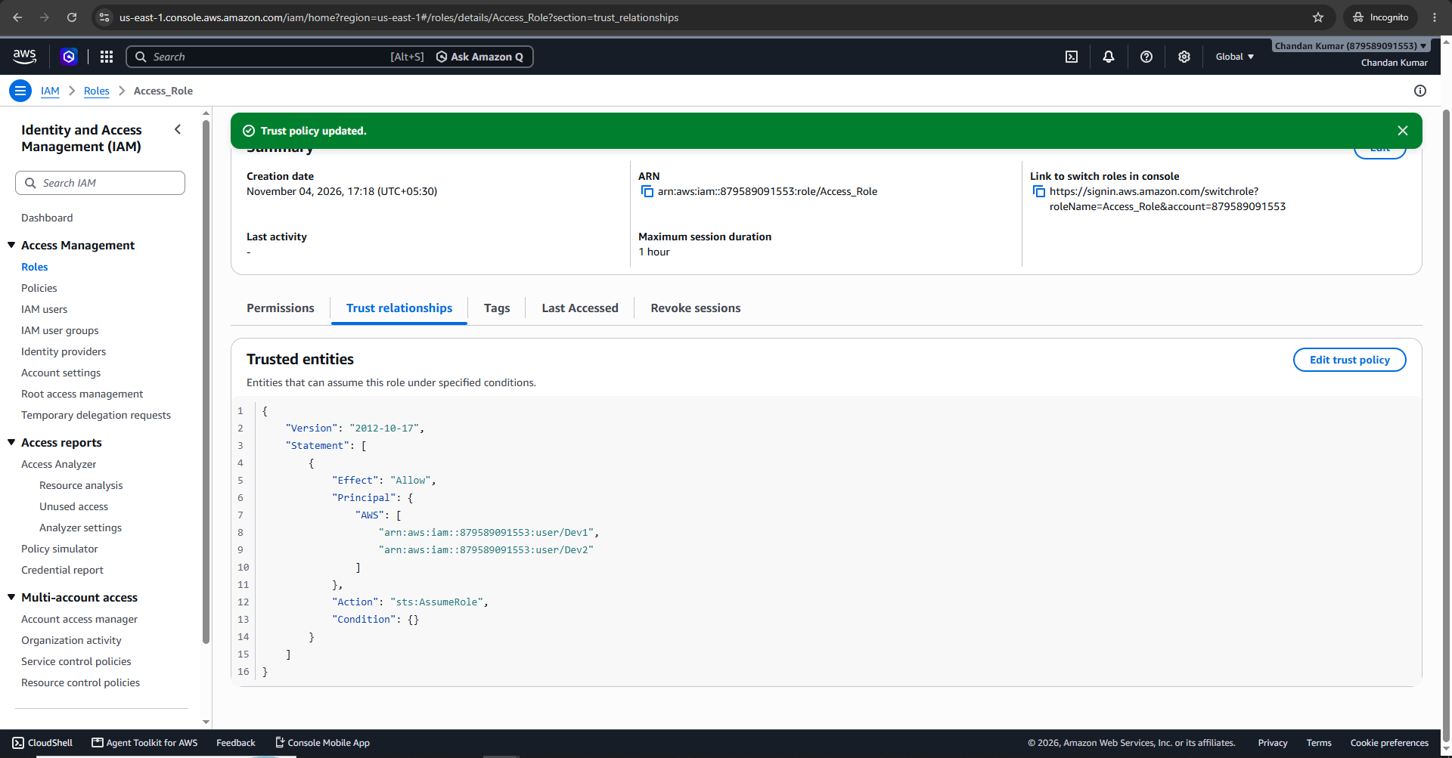
Step 7: Click on permission > add permission > Attach policy > add policy (VPC_DynamoAccess)> ok.
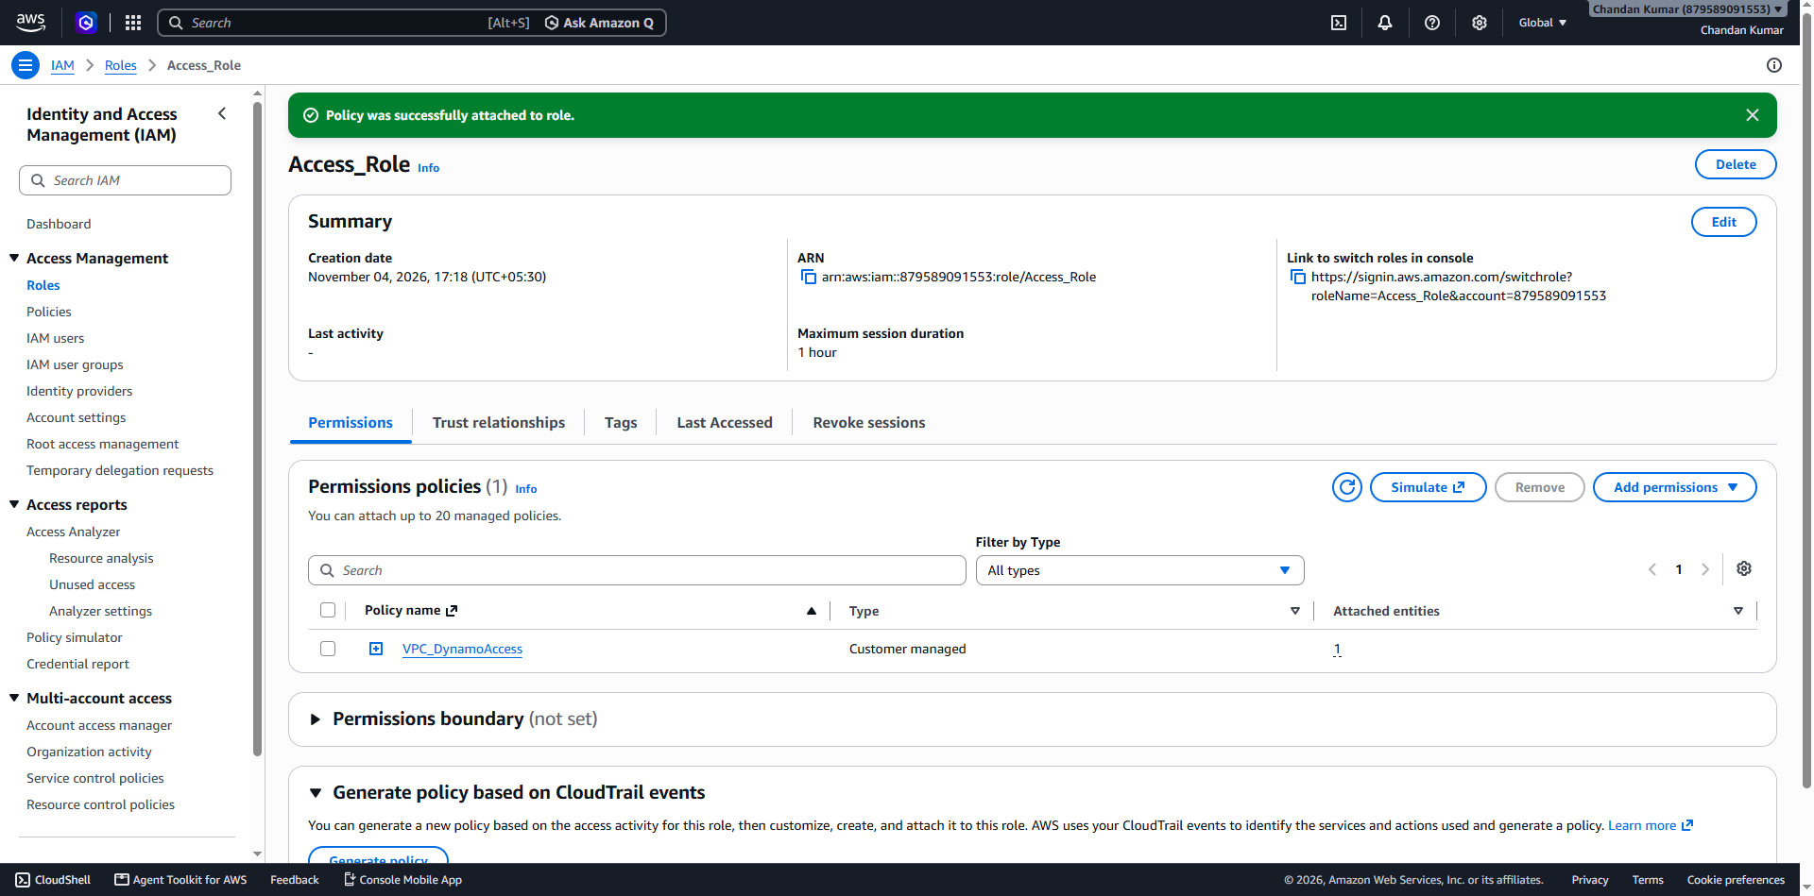
Step 8: Go to another tab > login aws > enter account number(879589091553) > IAm user name (dev1) > pass() > ok.
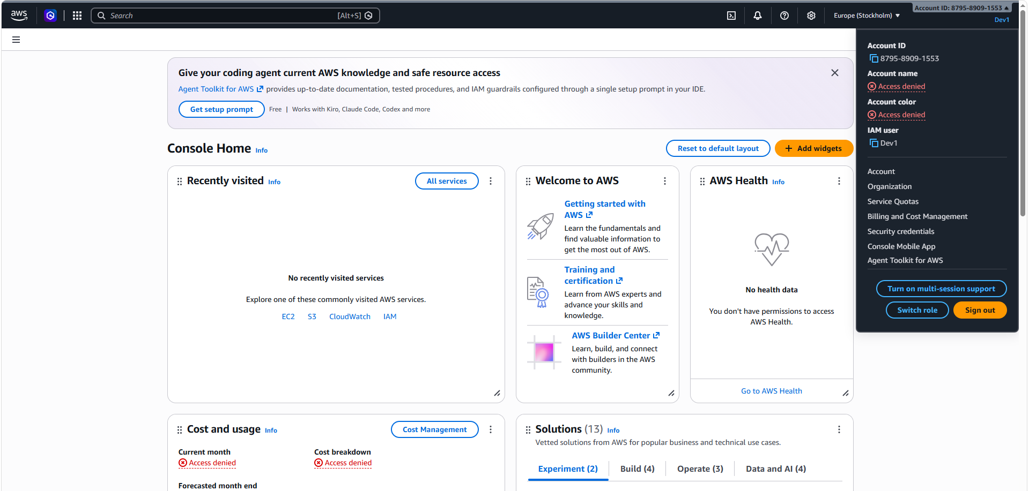
Step 9: Click on switch role >


